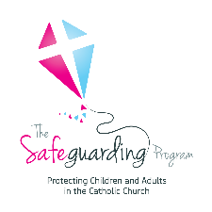
Catholic Archdiocese of Perth
SAFEGUARDING SURVEY
(SAMPLE FOR PARISH/AGENCY PARTICIPANTS)

Purpose:
To gauge the awareness of safeguarding in your community and help to improve and ensure that the parish/agency safeguarding efforts are effective.
Who:
Parish / Agency Participants
Instructions:
Before submitting the form, carefully review all your answers to ensure accuracy. Please use additional pages if needed.

Upon completion, the form is to be submitted to the parish/agency office. This can be done by delivering, mailing, or submitting online.

If you encounter any difficulties or have questions while filling out the form, don't hesitate to ask for assistance from a Safeguarding Officer within the Parish/Agency responsible for the survey.
Questionnaire:
- Do you understand safeguarding in our community? | ☐Yes | ☐No
- Do you understand the role of the Safeguarding Officer?
☐ I have no idea what they do.
☐ I understand their role a little.
☐ I understand their role well.
- Do you know how to contact a Safeguarding Officer if there is a question or concern? | ☐Yes | ☐No
- How confident are you in the Safeguarding processes?
☐ Very confident.
☐ A little confident.
☐ Not confident at all.
- How important is the Safeguarding Program to you?
☐ Very.
☐ Somewhat
☐Not important
- Do you have any suggestions for improving safeguarding in your community?
________________________________________________________________________________________________________________________________________________________________________________________________________________________________________________________________

